**Analogues**

// To find analogues, first the four structures were run against approved FDA drugs, if no results showed up there, then the Experimental database was used//

Galidesivir

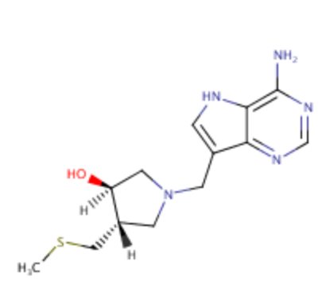Analogue 1 – from Experimental database with similarity 0.264

[H][C@]1(O)CN(CC2=CNC3=C(N)N=CN=C23)C[C@]1([H])CSC

Mr= 293.39

LogP= 0.56

HBD: 3

HBA: 4

Could be used to probe for hydrophobic pocket as well as analyse H-bond activities on 5 membered ring due to hydroxyl groups

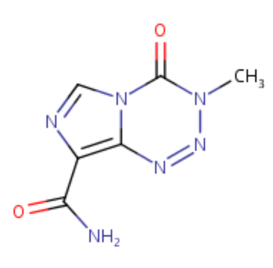Favipiravir

Analogue 1- from FDA approved database with similarity 0.065

Mr= 194.15

LogP= -0.84

HBD: 1

HBA: 5

Structure expansion, more vdW contacts, maintaining supposed active site, probing for hydrophilic pocket

Remdesivir (None found via SwissSimilarity)

Designed manually to reduce highlighted problem areas (marked in red on candidate sheet):

Analogue 1 - Structure Truncation to determine which part of tail is neccessary

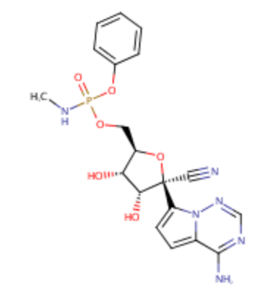N#C[C@]1(O[C@@H]([C@H]([C@H]1O)O)COP(=O)(Oc1ccccc1)NC)c1ccc2n1ncnc2N

Mr= 460.38

LogP= -0.2

HBD: 4

HBA: 10

Analogue 2 - Structure Truncation to determine which part of tail is necessary

CCC(COC(=O)[C@@H](NP(=O)(OC[C@H]1O[C@@]([C@@H]([C@@H]1O)O)(C#N)c1ccc2n1ncnc2N)O)C)CC

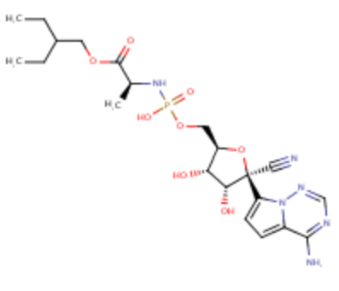Mr= 526.48

LogP= -0.08

HBD: 5

HBA: 12

Ribavidin Triphosphate

FDA approved screen only returned ATP (not possible) and Ribavidin (no longer prodrug)

From Experimental:

Analogue 1 – Structure ridgidification

O[C@@H]1[C@@H](COP(=O)(OP(=O)(OP(=O)(O)O)O)O)O[C@H]([C@@H]1O)N1CN(c2c1[nH]c(N)nc2=O)C

Mr= 539.22

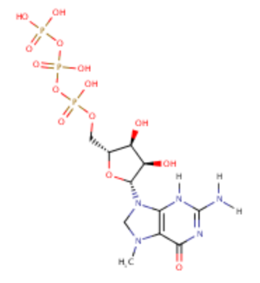LogP= -4.34

HBD: 8

HBA: 15